Endorsement Terms for The Society of Cardiovascular and Pulmonary Rehabilitation
Definition: The Society of Cardiovascular and Pulmonary Rehabilitation (SOCVPR) defines endorsement or recognition as formally expressing approval and acknowledging the overall objectives, content, and potentially the planning and preparation process of a program, project, Product or initiative.
The Society of Cardiovascular and Pulmonary Rehabilitation (SOCVPR) considers endorsement or recognition as the formal approval and acknowledgment of the overarching goals, content, and possibly the planning and preparation involved in a program, project, or initiative.
Fees:
The application fee for endorsement of a product/program is ₹50,000, and if the product/program is approved, there is an annual endorsement fee of ₹1,50,000 per calendar year for profit-driven ventures and products and programs. The endorsement fees have to be paid in total on approval eg if for 2 years – Rs 300,000/- on approval
The endorsement fees are subject to revision based on the decisions made by the Executive Committee of SOCVPR.
Research Collaborations: The SOCVPR is open to research collaboration and an email to the effect has to be mailed to the President and Secretary
Process to Solicit Support, or Endorsement / Recognition:
Application Form and Payment Details: Please find attached the application form along with the payment details:
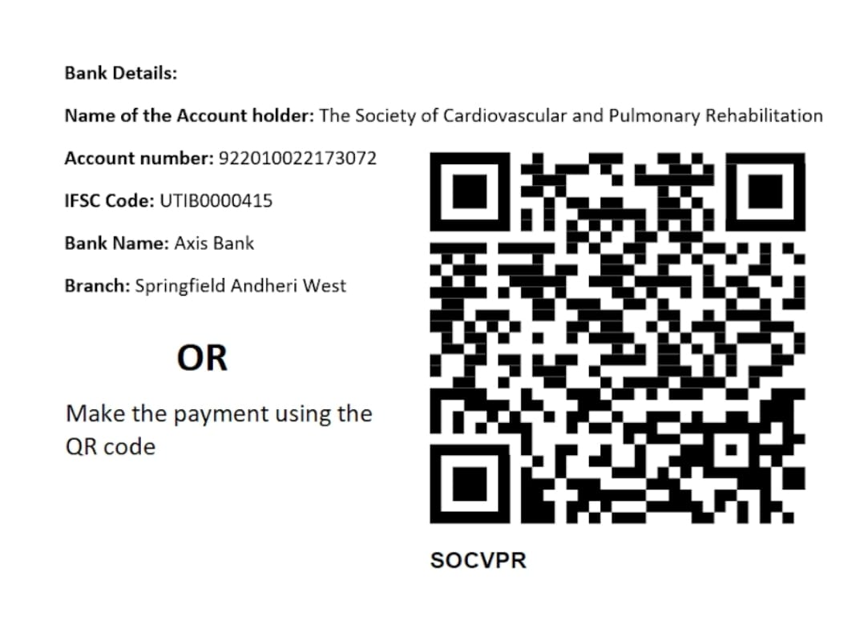
Involved Members: Kindly provide the names of both SOCVPR members and non-members who are participating in the project.
Budget and Funding Sources: Please submit the project budget and disclose all sources of development funding to ensure there are no conflicts of interest.
Supporting Organizations: If there are other organizations supporting or endorsing the project, please provide a list of these entities.
Approval Process:
- Please note that payment of the fee does not guarantee automatic approval. The request will be reviewed by the President, Vice President and Secretary. If there are uncertainties about whether the project aligns with all policies or concerns about the wording of support or endorsement, the Executive Committee will be consulted, following the process outlined below. Please provide an answer to all the points in application form.
- A decision on the project's eligibility for approval will be made within 1 to 2 months.
Eligibility Criteria:
- The project must have international, national, or regional significance or be recognized as highly important to SOCVPR.
- Ideally, the request should be initiated by an SOCVPR member who has actively contributed to the project’s development or implementation.
- The project must align with the SOCVPR mission.
Update on your Application:
- The SOCVPR Secretary will notify the requestor of the decision via email. This notification will include the approved final language and specify whether and in what capacity the SOCVPR logo can be used for the project or initiative.
- Once approved, the logo and statement may only be added to the project website after payment has been received. After posting, the requestor must provide the website link to SOCVPR to confirm compliance with policy.
- If subsequent annual payments are not received within 14 days of the invoice, the endorsement will be immediately rescinded.
- Non-compliance with these policies will result in the immediate rescinding of SOCVPR endorsement, and the party will have five business days to remove the SOCVPR logo and endorsement statement from their website.
APPLICATION FORM FOR ENDORSEMENT
Name of Company:
Contact Person Name:
Email Id:
Phone No:

ABOUT PROGRAM/Product
Program/Product Module Name:
Brief Description:
Target Audience:
What is the programs’/Product purpose and goals?
What are the programs/Products scientific basis and evidences supporting its effectiveness?
How will you ensure that the program delivery is by Trained and credential verified therapists?
Name of the members involved in the Program/product
How will the program align with SOCVPR mission and vision?
Will the companies that utilize the program module be willing to partner with us in CSR initiatives, specifically supporting the mission and objectives of the Society? If Yes How?
Risk Assessment: Provide a comprehensive risk assessment of the digital rehab program, including any potential adverse effects or injuries related to the use of the program.
Safety Protocols: Specify the safety protocols that will be implemented to prevent or manage any adverse effects, and clarify the procedure for reporting and handling incidents.
How will the company handle any adverse effects or program related injury?
Liability for Adverse Events: Clearly define who is legally responsible in the case of adverse events, injuries, or other negative outcomes associated with the program.
Indemnity Clause: The company should indemnify the Society against any legal claims arising from the use of the endorsed program

Compliance with Local Laws: Does the program comply with all local, national, and international laws and regulations, particularly those related to medical devices, digital health, and telemedicine. Please provide details
Data Collection and Storage: Please explain how the patient data will be collected, stored, and managed securely. This should include adherence to relevant data protection laws and guidelines on who will have access to the data.
Data Anonymization: How will the patient data be anonymized or de-identified before any analysis or sharing to protect patient privacy
Data Breach Protocol: Does the company have a clause requiring the company to have a clear, actionable plan in case of a data breach. This should involve immediate notification to the Society and affected patients, as well as measures to mitigate the impact of such a breach.
Consent : Informed Consent: Process for obtaining informed consent from all participants, detailing what data will be collected, how it will be used, and who it will be shared with.
Right to Withdraw clause: Patients should have the right to withdraw their consent at any time without penalty or loss of benefits.

Intellectual Property Rights: Clarify the ownership of intellectual property related to the digital rehab program. This includes software, data, and any other proprietary materials used or developed in connection with the program. If the SOCVPR is involved in designing the program the intellectual property rights will be shared with the SOCIETY OF CVPR.

Program Evaluation and Monitoring:
Continuous Monitoring: Please specify the clause requiring ongoing monitoring and evaluation of the program’s effectiveness and safety. The company should provide regular reports to The Society on the program’s performance and any incidents.
Audit Rights: The Society of CVPR should have the right to audit the program to ensure compliance with the agreed-upon terms and standards
Transparency and Disclosure:
Disclosure of Conflicts of Interest: Require full disclosure of any conflicts of interest, including financial relationships between the company and any healthcare providers involved in the program.
Transparency in Outcomes: The company should commit to transparent reporting of both positive and negative outcomes of the program, including publishing results in peer-reviewed journals where possible. Acknowledgement of The SOCIETY OF CVPR should be in such publications

Endorsement Termination: Include a clause that allows the Society to terminate the endorsement if the program fails to meet agreed-upon standards, violates legal or ethical guidelines, or if significant safety concerns arise.

Suggest TWO reviewers for this program? The society of CVPR mat contact reviewers other than those suggested.
Are you ready to modify the program if the reviewers suggest so?
What is the duration of endorsement agreement seeked for?

Endorsement Terms:
1. By endorsing this program module, I agree to allow the company to use my company's name and logo in promotional materials.
2. I understand that my endorsement is valid for a period of [ time frame] and may be renewed upon mutual agreement.

________________ ____________________ ____________________
PRESIDENT VICE-PRSIDENT SECRETARY

